

**SCRUM Initiative – Business/Functional Requirements**

**Permissions / User Groups**

1. The system shall have the ability for a user to create permissions for Users / Groups:
   1. Administrator – Full Control
      1. Ability to Create Users
      2. Ability to Modify Users (delete)
      3. Ability to Create Groups
      4. Ability to Modify Groups
      5. Ability to Assign Permissions to Users / Groups
      6. Ability to Modify Permissions to Users / Groups
      7. Include “All User – Edit” Permissions
   2. User – Edit
      1. Ability to Create Projects, Stories, Tasks List
      2. Ability to Modify & Manage Projects, Stories, Tasks List
         1. Delete Projects, Delete Stories, Delete Tasks from Tasks List.
         2. Add and Remove Points from Projects, Stories, Task List
   3. Guest – Read Only
      1. Ability to View all Projects, Stories, Tasks List but no access to modify.
2. The system shall have the ability to Date & Time Stamp with User Name whenever any user modifications (create, delete, permissions, etc.) are made.
   1. This is to include:
      1. User Creation
      2. User Assignment to Groups
      3. Group Creation
      4. Group Modifications
      5. Project Creation
      6. Project Modifications
      7. Story Creation
      8. Story Modification
         1. Add new stories
         2. Delete stories
         3. Update points for Story
      9. Task List Creation
      10. Task List Modification
          1. Add new tasks
          2. Delete tasks
          3. Update points for Tasks
      11. Point Assignment
      12. Point Modification
3. The system shall have the ability for an Administrator to assign a user to a Project, Story, Task List.
4. The system shall have the ability allow the Administrator to manage usernames and passwords.
   1. Reset Passwords
   2. Assign Passwords
   3. Modify User Accounts

**User Interface** (refer to Image below for reference)

1. The system shall have the ability for display a splash screen upon opening the application.
2. The system shall prompt the user to enter a user name and password.
3. The system shall validate the username and password for accuracy.
   1. In inaccurate after 5 login attempts, the system shall disable future login attempts until the administrator resets the password.
   2. The system shall have the ability send a notification to the administrator to reset the password.
4. The system shall have the ability for the user to create a Project / multiple Projects.
5. The system shall have the ability for the user to designate Total Points for the Project.
6. The system shall have the ability for the user to create a Story / multiple Stories.
7. The system shall have the ability for the user to designate Total Points for the Story.
8. The system shall have the ability for the user to create a Task List.
9. The system shall have the ability for the user to designate points per each Task in the Task List.
10. The system shall have the ability to sum the points for the Task List and update the Story / Stories and Project / Projects.
11. The system shall have the ability to sum the points for the Task List and validate against the Story / Stories and Project / Projects for accuracy (make certain points match from bottom to top).
12. The system shall have the ability for a user to update the points per task and aggregate the total points for the said Story and Project.
13. The system will be designed to incorporate the following into the Tasks List (table with the following column headers / field names):
    1. Sprint
    2. Employee
    3. Story
    4. Task Name
    5. Date Assigned
    6. Date Completed
    7. Days to Complete
    8. Points Assigned
    9. Points Completed
14. The system shall have the ability for a user to sort the UI Table (ascending and/or descending) based on the headers / field names on BR # 13.
15. The Scrum Dashboard will have at minimum 8 separate quadrants.
    1. These quadrants will house Projects, Stories, Tasks List.
16. The Scrum Dashboard will have the ability for an Administrator to add quadrants.
17. The Scrum Dashboard will have the ability for an Administrator to remove quadrants.
18. The Scrum Dashboard will have the ability for an Administrator to name each quadrant.
    1. Default Names:
       1. Dreams
       2. Novels
       3. Epics
       4. Stories
       5. Sprint Backlog
       6. Doing
       7. Done
       8. Information Locked
19. The Scrum Dashboard will have a search feature / widget to query and obtain specific data:
    1. User Name with all corresponding Projects, Stories, Tasks List, and aggregate of all points.
    2. Date with all corresponding Projects, Stories, Tasks List, and aggregate of all points.
       1. From Field and To Field
          1. Widget (Calendar)
          2. Free Form Field with acceptable Date Formats.
    3. Projects with aggregate of all Stories, Task Lists and all points.
    4. Stories with aggregate of all Projects, Task Lists and all points.
    5. Task List with aggregate of all Projects, Stories, and all points.
20. The system shall have the ability for a user to Drag & Drop Projects, Stories, Tasks Lists, etc. through all the quadrants.
    1. The system shall automatically Date & Timestamp with the user’s name whenever a Drag & Drop transaction has occurred.
21. The system shall have the appropriate format in place to allow access from various mediums.
    1. This is to include:
       1. Tablet
       2. PC
       3. Mobile Phone (iOS and Android)
22. The system will have the ability to prompt for confirmation whenever a change is made:
    1. Modification of any Projects, Stories, Tasks List, Point Movements, etc.
23. The system will complete the transaction once the prompt has been approved.
24. The system will have the ability to export the table and the query results into Excel, PDF, JPEG, PowerPoint, etc.

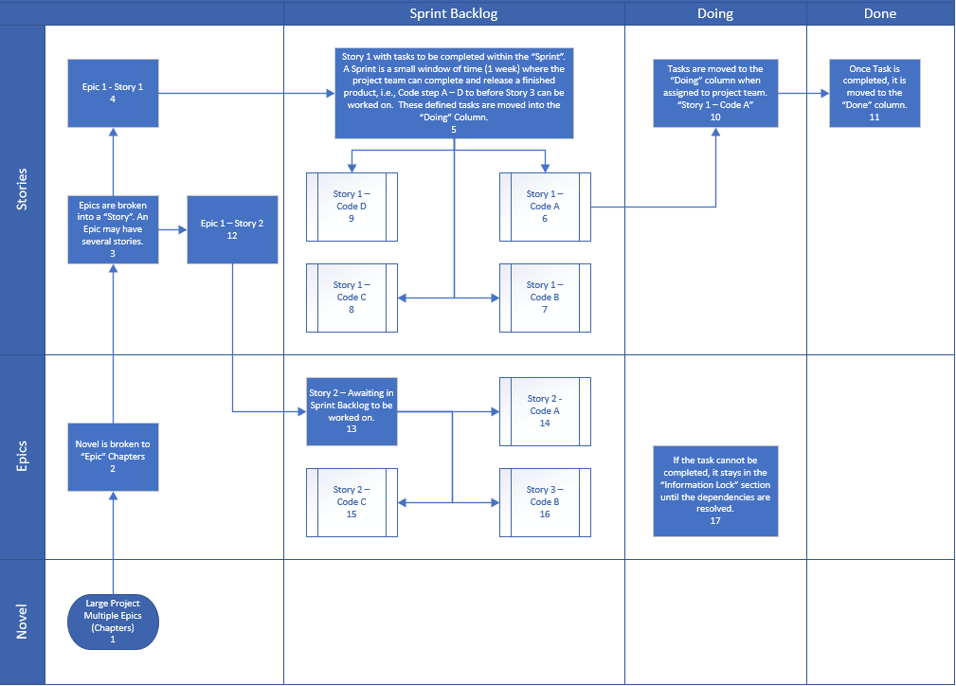

**Burn Down Chart** (refer to Image below for reference)

1. The system shall have the ability to create a burn down chart for multiple Projects.
2. The system shall have the ability to create a burn down chart for each Project.
3. The system shall have the ability to consolidate multiple Projects into one Burn Down Chart.
4. The Burndown Chart will be formatted as a combination chart:
   1. Columns and Line Graph.
5. The Burndown Chart will consist of Points Completed Per Day formatted in a Column Chart on the X axis.
6. The Burndown Chart will display the Days of the Project on the X axis.
7. The Burndown Chart will display the Total Points on the Y axis.
8. The Burndown Chart will display the Points Completed on the Y axis.
9. The Burndown will have the ability to subtract the “**Actual Points**” from the “Remaining Actual Points” and illustrate this as a line graph burning down.
10. The Burndown will have the ability to subtract the “**Planned Points**” from the “Remaining Planned Points” and illustrate as a line graph burning down.
11. The Burndown Chart will be able to forecast the completion of Actual Points via a line graph to a specific date.
12. The Burndown Chart will be able to forecast the completion of Planned Points via a line graph to a specific date.
13. The system shall be able to aggregate all Stories, Task Lists, and associated Points and illustrate on Burn Down Chart.
14. The aggregation of the Projects, Stories, and Tasks List will occur in real time.
15. The system shall have the ability to export all data, i.e., charts, tables, visualizations, etc., to Excel, PDF, JPEG, PowerPoint, etc.
16. The system shall have the ability to format the data for printing purposes.
17. The system shall have the ability to obtain the average points completed within any given time frame.
18. The Burndown Chart will have the ability to aggregate the Total Task Per User.
19. The Burndown Chart will have the ability to aggregate the Total Assigned Points Per User.
20. The Burndown Chart will have the ability to aggregate the Total Points Completed Per User
21. The Burndown Chart will have the ability to aggregate the above information as it pertains to Sprints.
22. The Burndown Chart will have the ability to count and sum the Total New Projects created per User.
23. The Burndown Chart will have the ability to count and sum the Total New Stories created per User.
24. The Burndown Chart will have the ability to count and sum the Total New Tasks created per User.
25. The Burndown Chart will have the ability to count and sum the Total Modifications Made to a Project per User.
26. The Burndown Chart will have the ability to count and sum the Total Modifications Made to a Story per User.
27. The Burndown Chart will have the ability to count and sum the Total Modifications Made to the Task Lis per User.
28. The Burndown Chart will have the ability to determine the velocity of points (average) completed per day, week, month, and year.

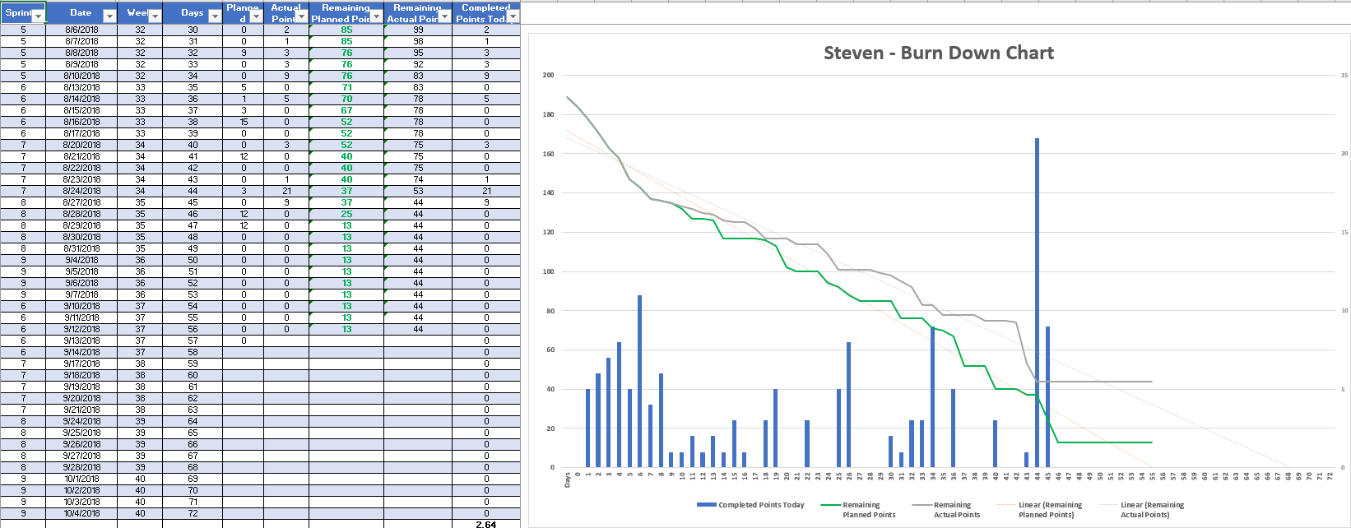

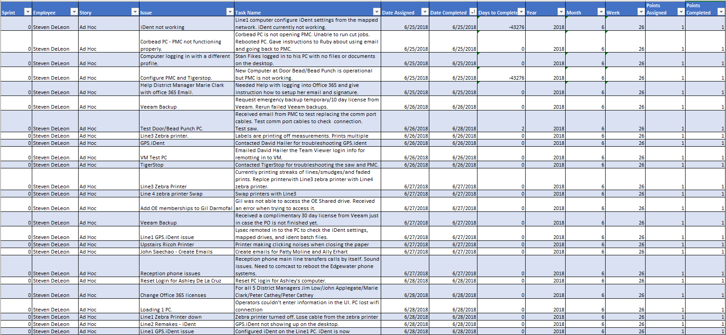

**Database**

1. The system shall be able to link directly into a database to extract and write data.
2. The system shall have redundancies in place to restore from a back-up or last know good save.